**Lab1:**

**Student1: Student2:**

**NAME: Qiguo Qin NAME:Yujun Ma**

**MUID:20124023 MUID:20124007**

**FZUID:832002127 FZUID:832002128**

**Object:**

The purpose of this experiment is to construct a logical inverter composed of PMOS and NMOS. In this experiment, the characteristics and non-ideality of the inverter will be studied.

**Fig1:**

The circuit wiring diagram is as follows: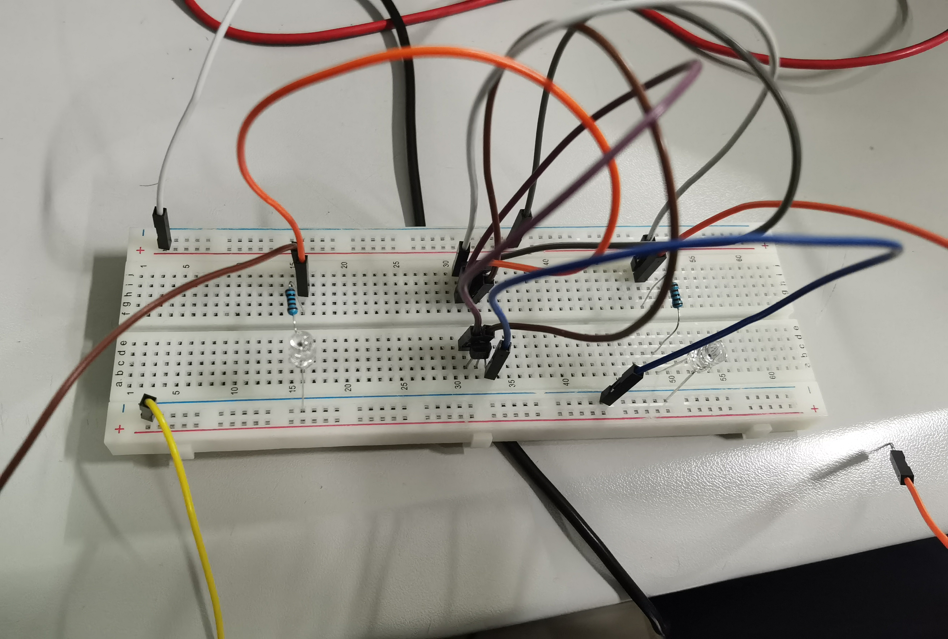

**Fig2:**

We use the function generator, set the amplitude to 4VPP and the signal frequency to 10HZ, and then connect the oscilloscope to observe the correct square wave as shown in the figure below.

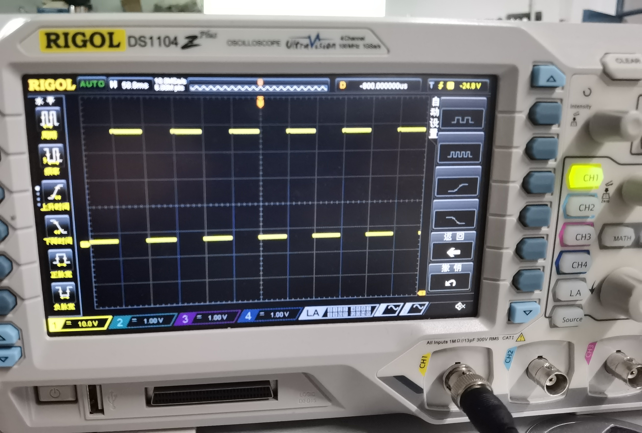

**Fig3:**

When 2 LED lights flash alternately, oscilloscope waveform display is as follows:

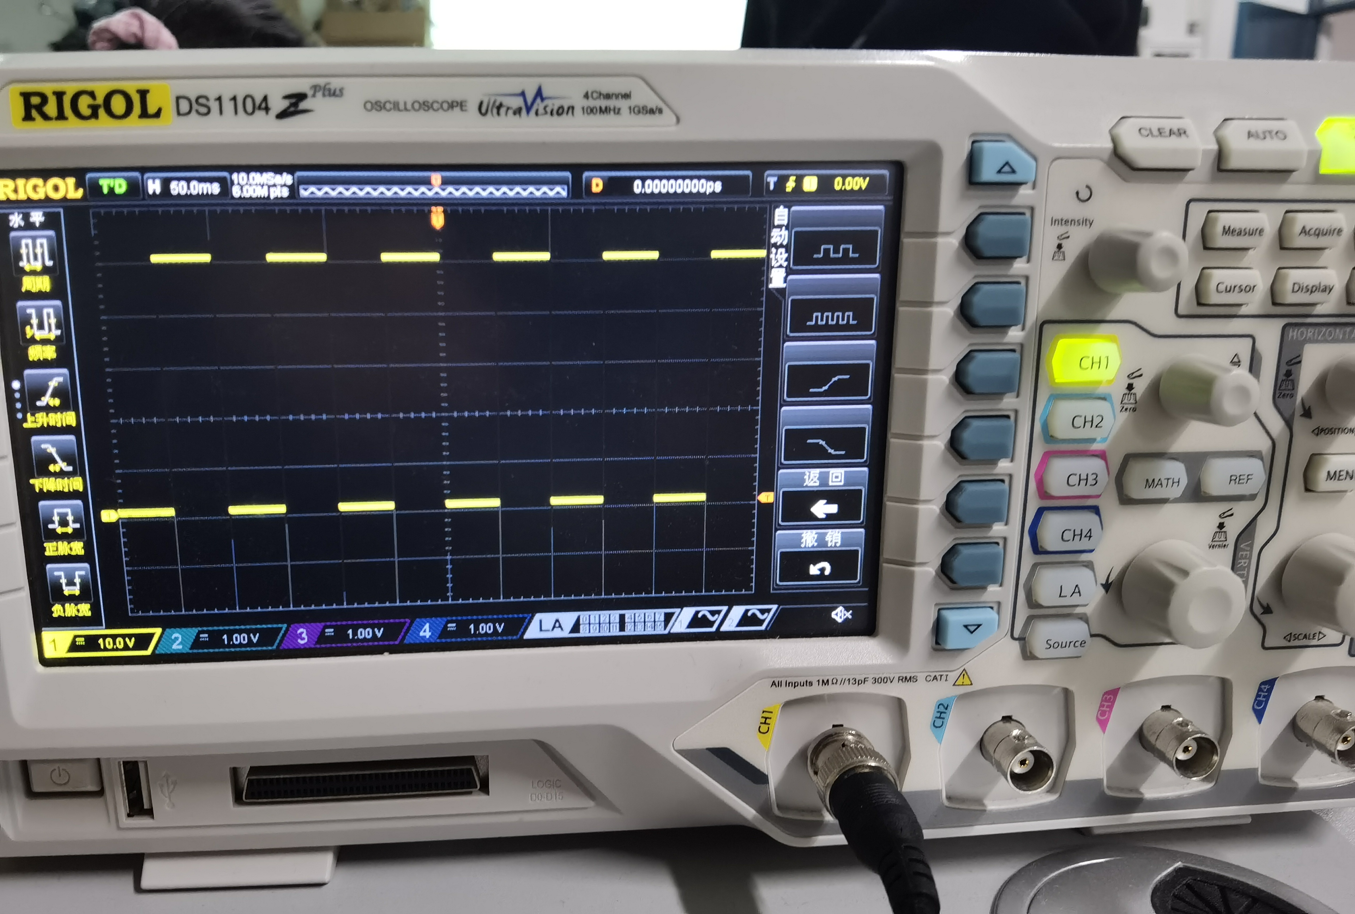

They are square.

**Fig4:**

Aim at a rising edge and continuously zoom in on the abscissa, you can see a signal that is not a square wave, as shown in the following figure:

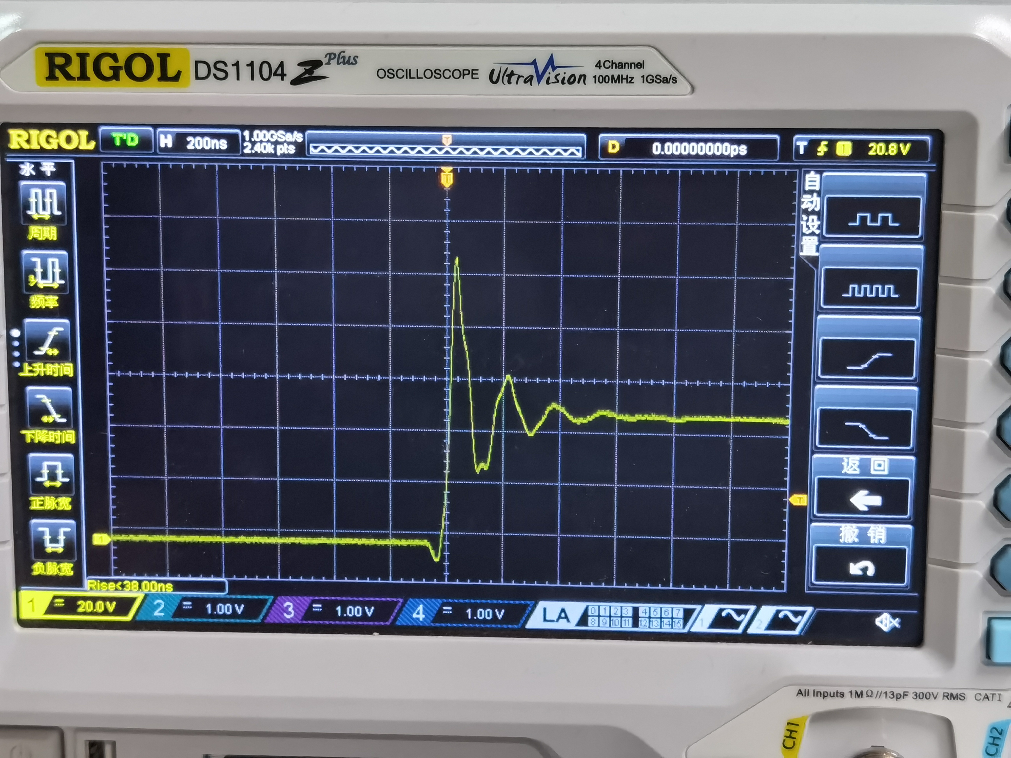

回答问题：描述您所看到的，并评论您认为可能如何影响数字电路的性能。评论你认为这种行为是如何出现在一个电路中的。

**Lab2:**

**Fig5:**

When we remove 1K-resistance and LED at the output-end and connect a 1uF-capacitor, the circuit wiring diagram is shown as follows: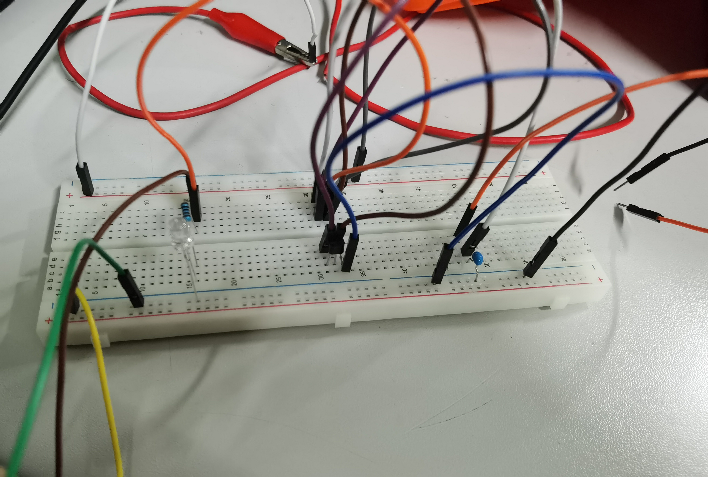

**Fig6:**

The input and output waveforms are as follows:

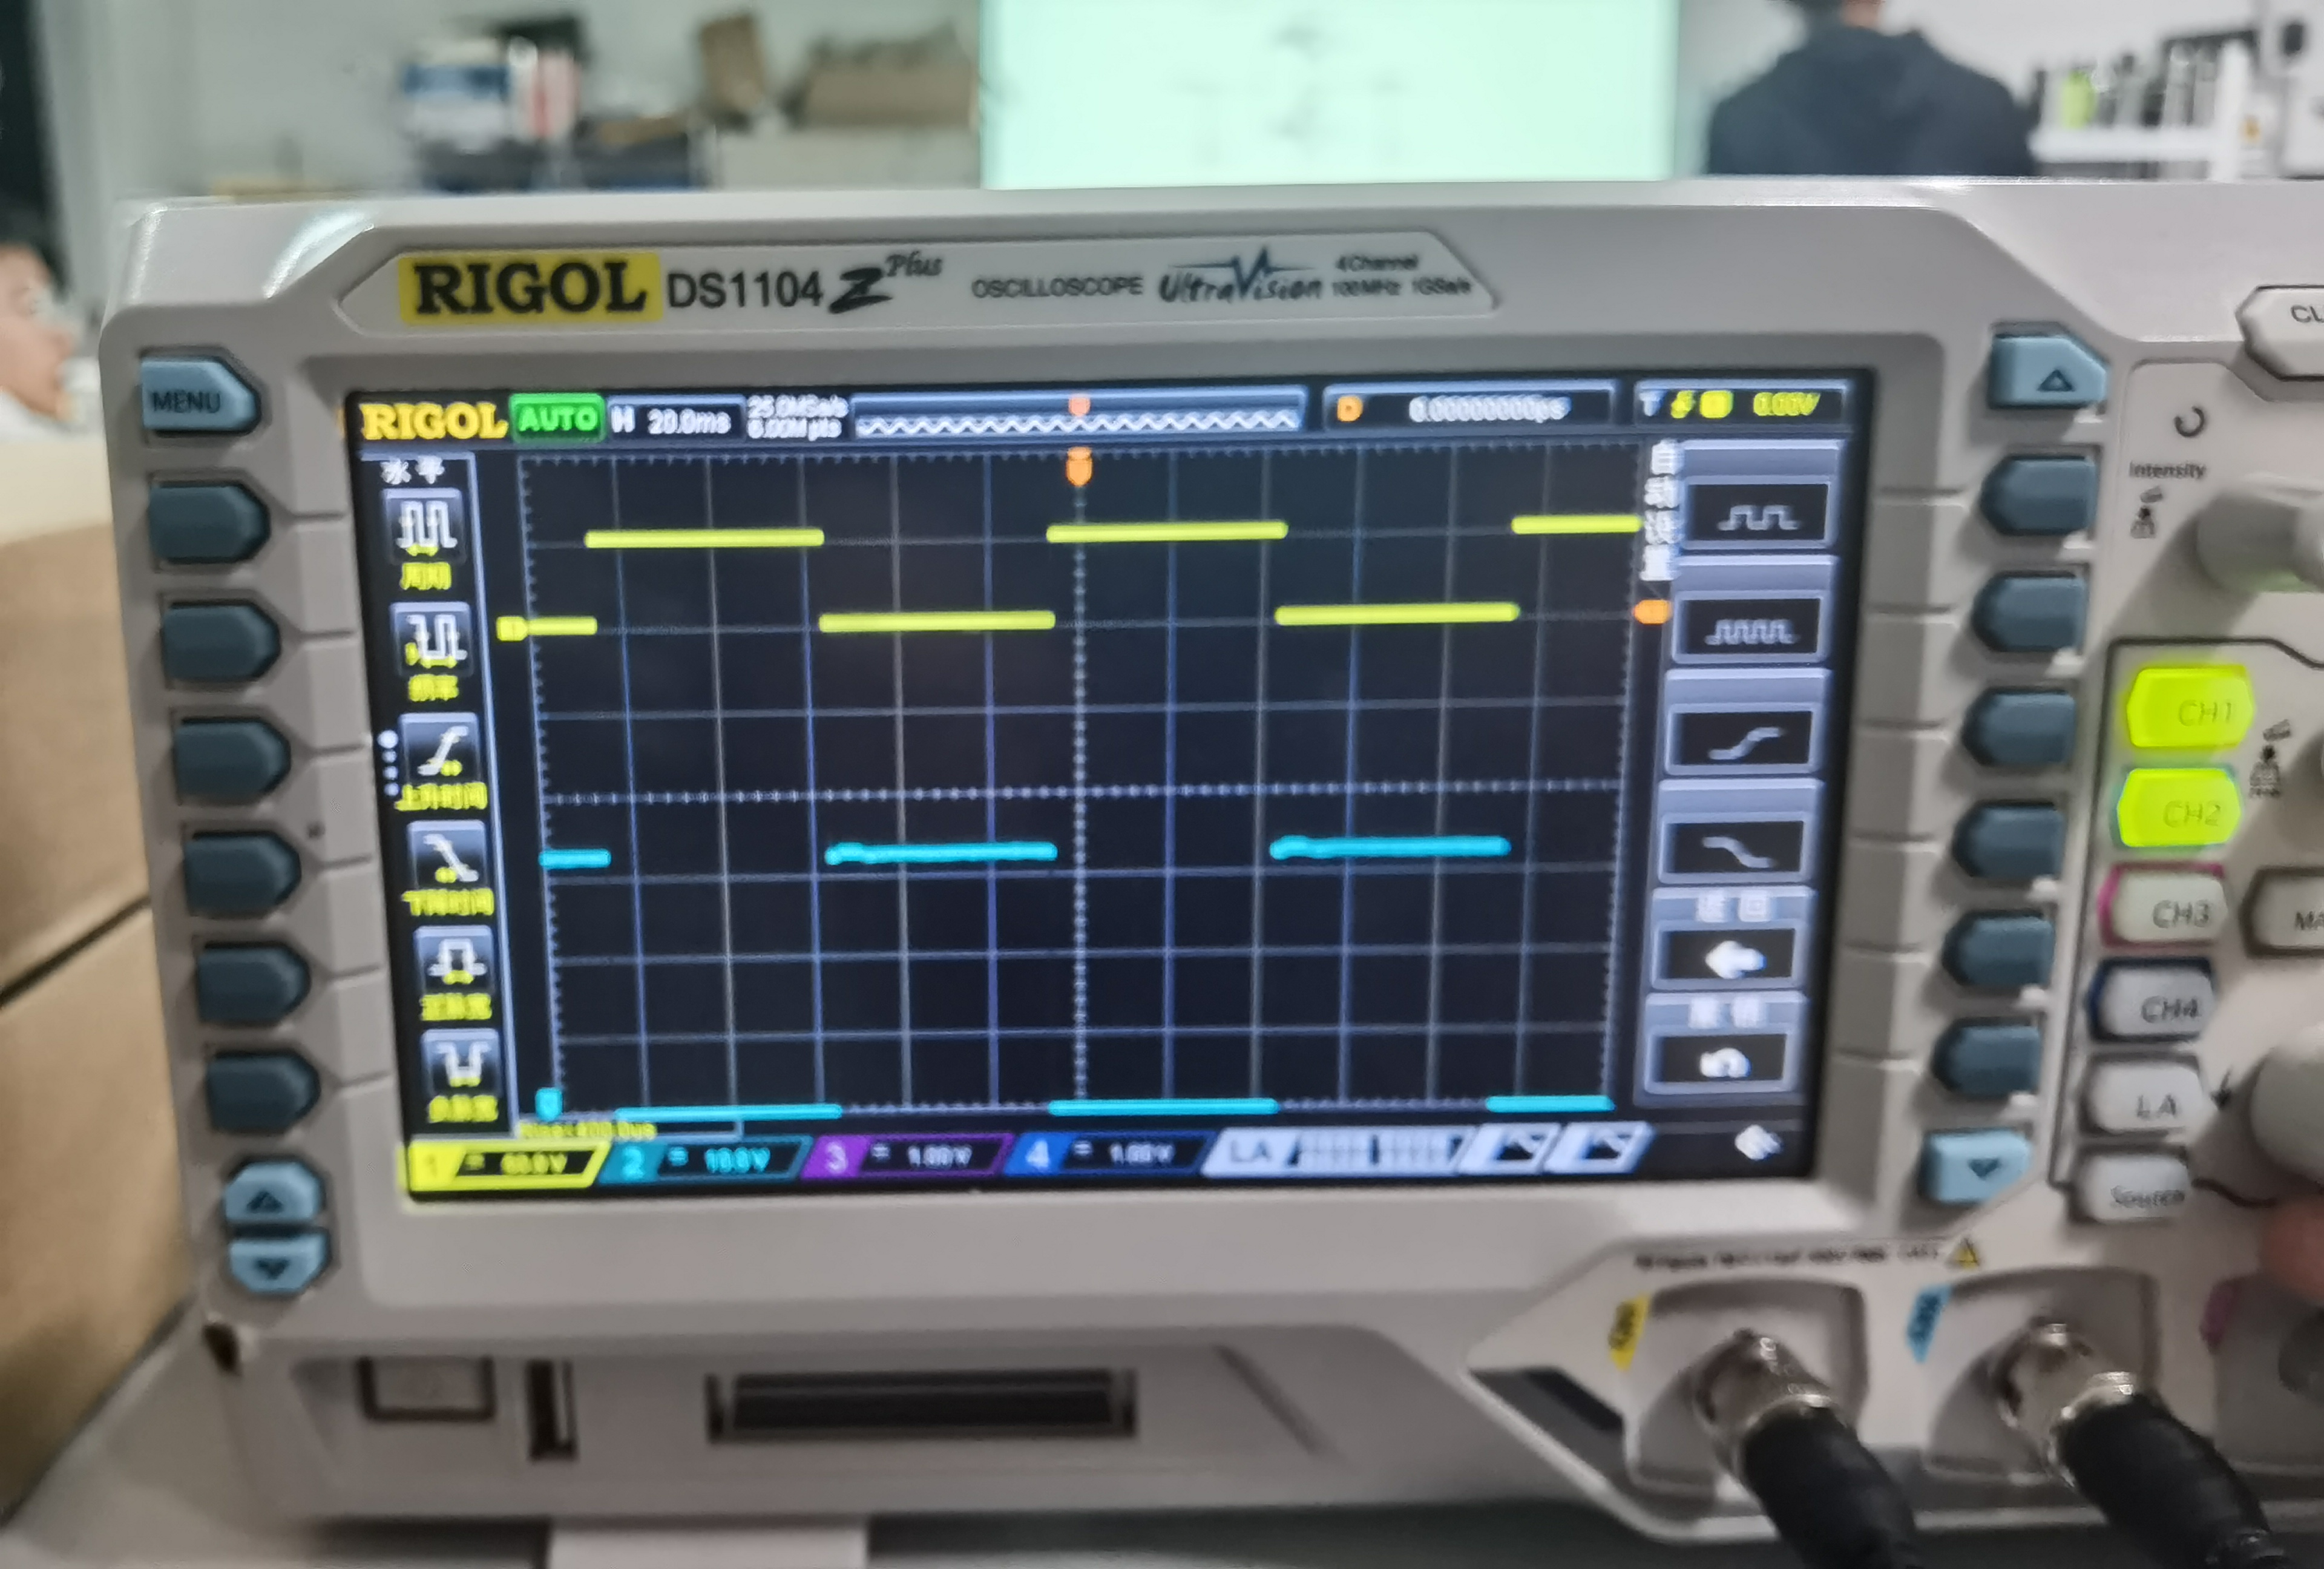

When we aim at a rising edge and continuously zoom in on the abscissa, we can see that the signal is not a square wave:

1. The amplitude to 4VPP and the signal frequency to 10HZ:

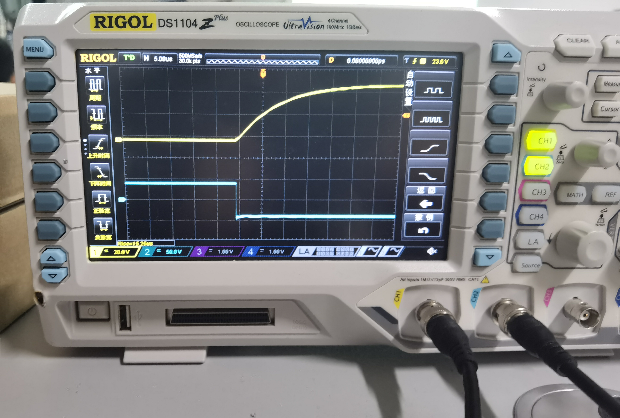

2)When we set the frequency to 1000HZ:

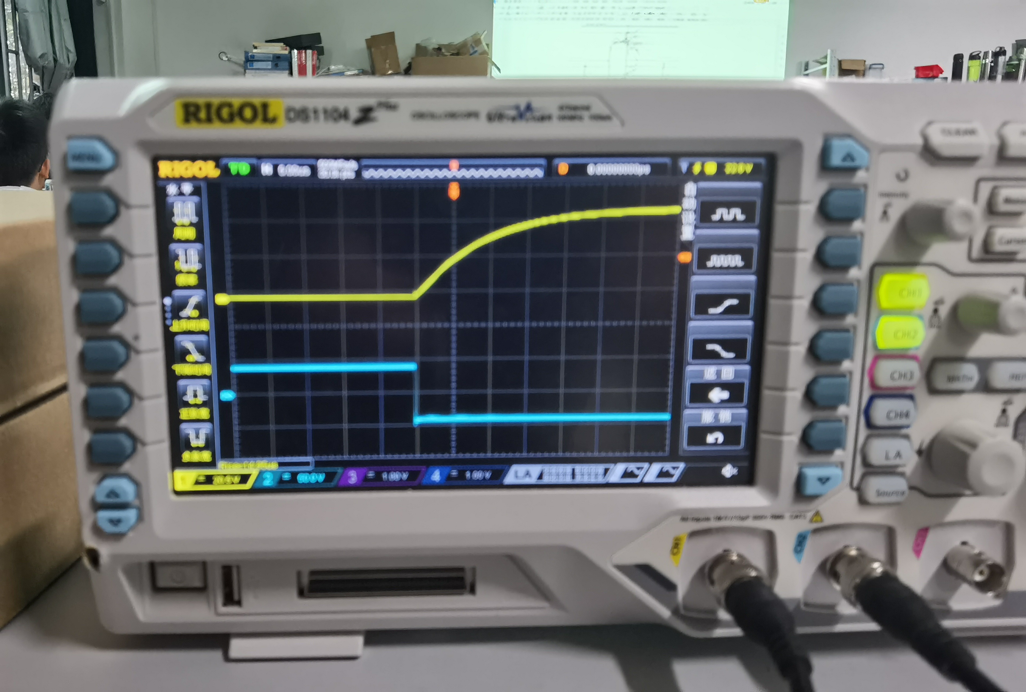

3)When we set the frequency to 10000HZ:

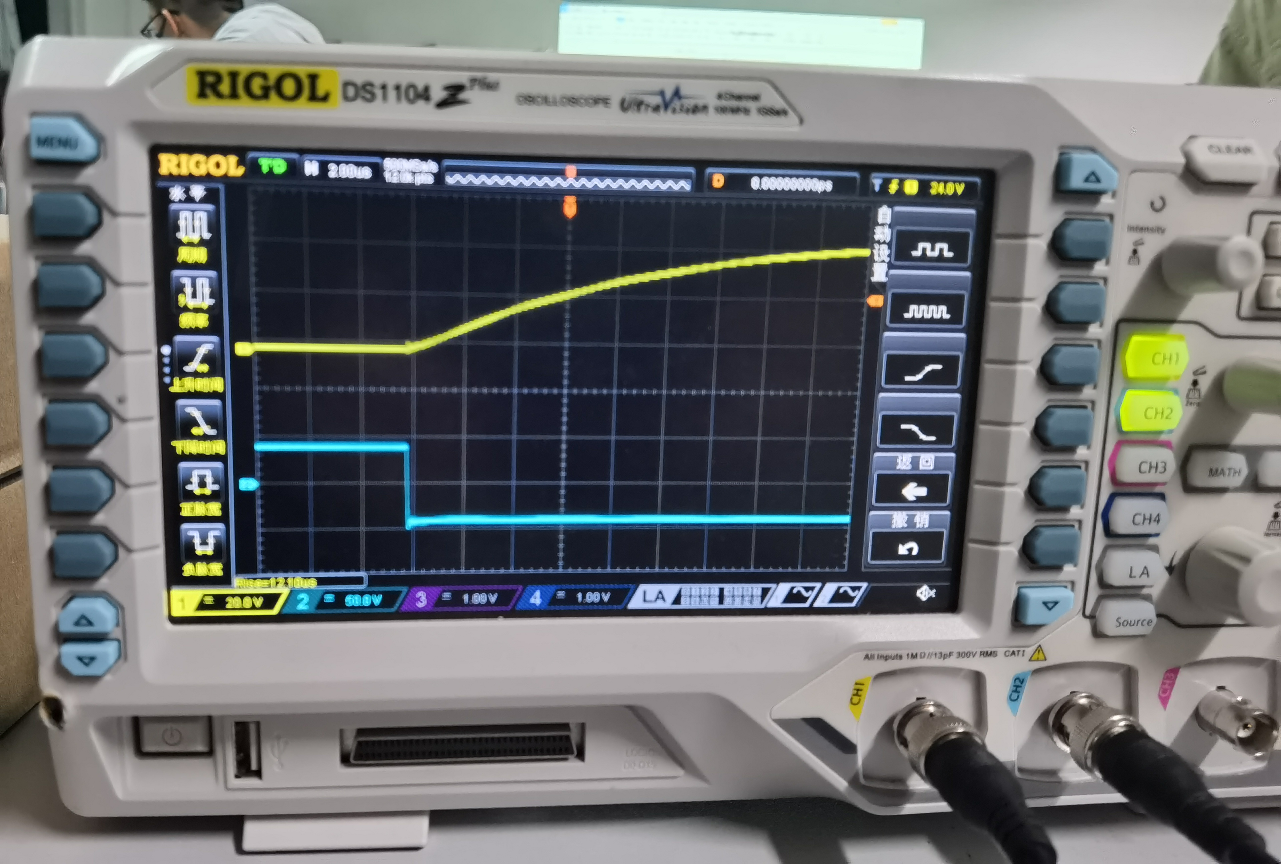

评论增加这个节点上的电容对性能的影响。绘制生成的波形。评论这将如何影响一个逆变器的高频操作。（观察不同频率下的波形，多个图）

**Summary:**

Through this experiment, we learned how to use function transmitter and oscilloscope, and mastered the circuit connection more skillfully. Not only that, we also recognize some factors that affect the performance of digital circuits. By changing the circuit structure and using capacitance, we know the impact of adding capacitance at a node of the circuit on the circuit performance. By changing different frequencies, we can get the impact of different frequencies on the inverter.